RPI_CM[x]_Carrier – Rev 2.00-0A – DVT report

BY

Jean-François Bilodeau
203-1690 rue des Quatre-saisons, Sherbrooke, CANADA, J1E 0N2
jeanfrancois.bilodeau@hotmail.fr
418-999-8845

APPLICABLE TO

RPI_CM[x]_Carrier – Rev 2.00-0A
Project release date: 2026-03
Setup date for qualification report: 9th of March 2026
Report release date: WIP
RPI_CM[x]_Carrier – Rev 2.00-0A – DVT report 1
Power supplies 3
1V8_CB 3
Buck qualification TPS54527DDAR 3
Brown-out 6
Brown-in 8
3V3_CB 10
Buck qualification TPS54527DDAR 10
Brown-out 12
Brown-in 14
5V0_CB 16
Buck qualification TPS54527DDAR 16
Brown-out 18
Brown-in 20
RESET 22
POWER-UP SEQUENCE 23
WARM RESET 26
HARDWARE WATCHDOG 27
POWER KILL 28
Test equipment 32

Power supplies

1V8_CB

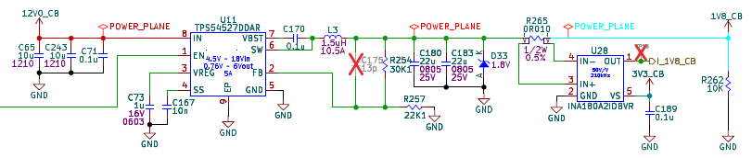
Buck qualification TPS54527DDAR

Reference
HW qualification | Reference | RPI_CM[x]_Carrier design notes
HW qualification | Applicable for | RPI_CM[x]_Carrier Rev 2.00-0A
Description |  | Detailed qualification of TPS54527 buck regulator for 1V8_CB rail
Test type |  | Internal | External | Site : Sherbrooke
Test status |  | To Do
Final test result |  | To Do

General Info
Date | 2026-03-09 | Temperature  Humidity | 25°C  50%RH
Realized by | Jean-François Bilodeau, P. Eng #6022173

System Information
Card/  Hardware | Serial Number | # Version | Mod (#WI) | Comments
Carrier Board
SOM
Accessory #1
Accessory #2

Assumptions
Based on design notes for a typical use-case:
- Typical Vout ~= 1.8V ±2%
- Typical Iout <= 0.8A
- Typical ripple ~= 20mVpp
- Typical soft start ~= 7.65ms ±15%
- Typical transient response ~= 300us ± 20%
- Typical switching frequency ~= 712.5kHz

Measurement point
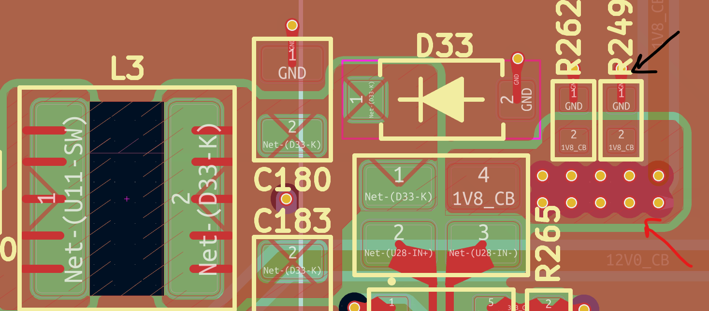  Measurement location for 1V8_CB Vout / Transient response qualification | Measurement location for 1V8_CB ripple qualification
Measurement location for 1V8_CB soft start qualification | 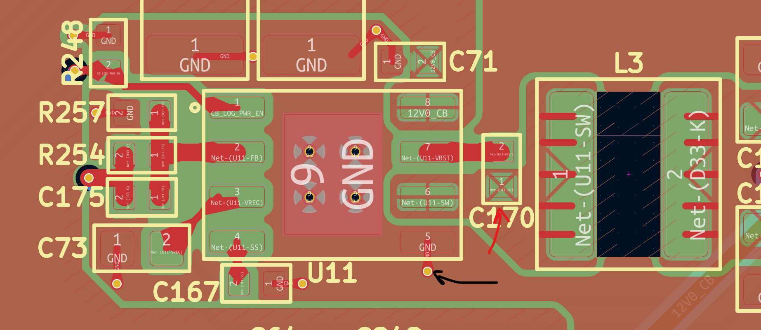  Measurement location for 1V8_CB FSW qualification

Test
1V8_CB Buck qualification | Test parameters
1V8_CB Buck qualification | Target | Measurement | Result | Comments
Vout | 1.75V <= 1.8V <= 1.825V
Ripple | <= 20mVpp
Soft start | ~ 7.65ms
Operating frequency | ~ 712.5kHz
Temperature increase vs ambient | <= 35DegC
1V8_CB buck qualification

Figures
1V8_CB - Vout | 1V8_CB - Ripple
1V8_CB - Soft start (0-80% output voltage) | 1V8_CB - Operating frequency
1V8_CB – Temperature increase

Conclusion

Brown-out
Reference
HW qualification | Reference | RPI_CM[x]_Carrier design notes
HW qualification | Applicable for | RPI_CM[x]_Carrier Rev 2.00-0A
Description |  | Detailed qualification of TPS54527 brown-out behavior for 1V8_CB rail
Test type |  | Internal | External | Site : Sherbrooke
Test status |  | To Do
Final test result |  | To Do

General Info
Date | 2026-03-09 | Temperature  Humidity | 25°C  50%RH
Realized by | Jean-François Bilodeau, P. Eng #6022173
System Information
Card/  Hardware | Serial Number | # Version | Mod  (#WI) | Comments
Carrier Board
SOM
Accessory #1
Accessory #2
Assumptions
Must measure minimum input voltage, output voltage ramp-up (Soft start) and inrush current
Measurement point
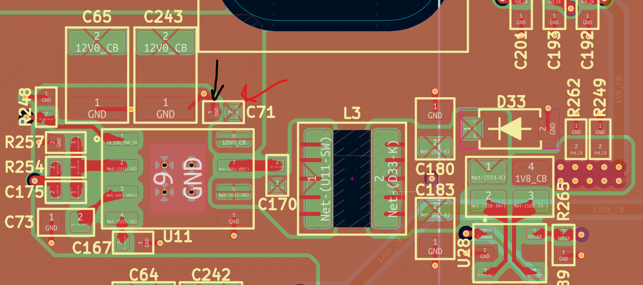  Measurement location for 1V8_CB minimum input voltage | 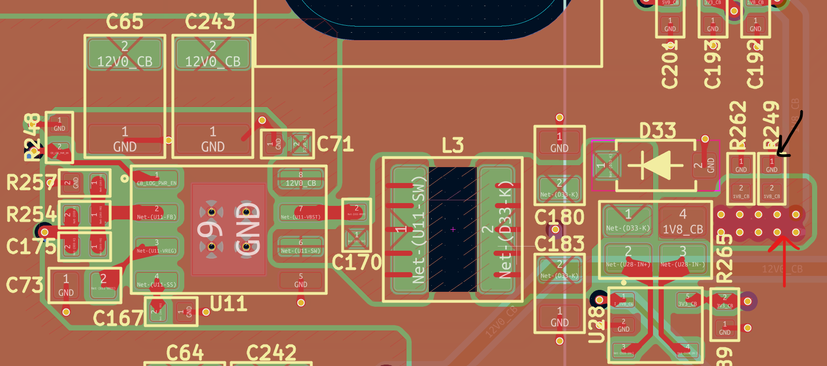  Measurement location for 1V8_CB soft-start validation
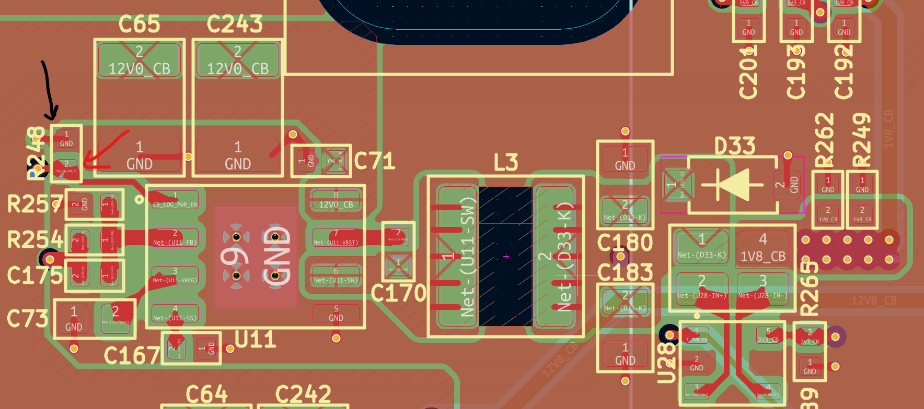  Measurement location for 1V8_CB EN input validation | 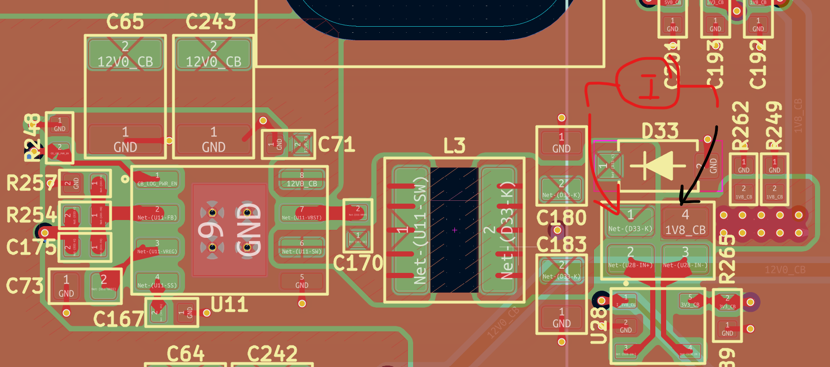  Measurement location for 1V8_CB inrush current
Test
1V8_CB Brown-out behavior | Test parameters
1V8_CB Brown-out behavior | Target | Measurement | Result | Comments
Minimum input voltage | >= 4.5V
EN input voltage “on” threshold | >= 1.6V
EN input to output ramp-up delay | < 1ms
Inrush current | INFO
1V8_CB brown-out behavior
Figures
1V8_CB Minimum input voltage | 1V8_CB EN input voltage threshold
1V8_CB EN input to output ramp-up delay | 1V8_CB Inrush current

Conclusion

Brown-in
Reference
HW qualification | Reference | RPI_CM[x]_Carrier design notes
HW qualification | Applicable for | RPI_CM[x]_Carrier Rev 2.00-0A
Description |  | Detailed qualification of TPS54527 brown-in behavior for 1V8_CB rail
Test type |  | Internal | External | Site : Sherbrooke
Test status |  | To Do
Final test result |  | To Do

General Info
Date | 2026-03-09 | Temperature  Humidity | 25°C  50%RH
Realized by | Jean-François Bilodeau, P. Eng #6022173
System Information
Card/  Hardware | Serial Number | # Version | Mod  (#WI) | Comments
Carrier Board
SOM
Accessory #1
Accessory #2
Assumption
Must measure input voltage ramp-down, output voltage ramp-down and power good assert
Measurement point
Measurement location for input voltage ramp-down | Measurement location for output voltage ramp-down

Test
1V8_CB Brown-in behavior | Test parameters
1V8_CB Brown-in behavior | Target | Measurement | Result | Comments
Input voltage brown-in | < 4.5V
Output voltage brown-in discharge | < 10ms
1V8_CB brown-in behavior
Figures
1V8_CB Input voltage brown-in threshold | 1V8_CB Output voltage brown-in discharge (100-10%)
Conclusion

3V3_CB

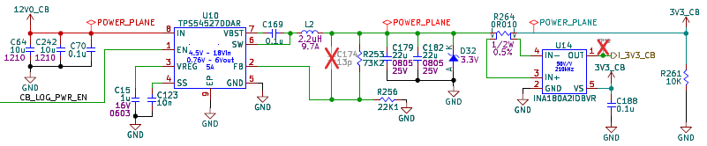
Buck qualification TPS54527DDAR

Reference
HW qualification | Reference | RPI_CM[x]_Carrier design notes
HW qualification | Applicable for | RPI_CM[x]_Carrier Rev 2.00-0A
Description |  | Detailed qualification of TPS54527 buck regulator for 3V3_CB rail
Test type |  | Internal | External | Site : Sherbrooke
Test status |  | To Do
Final test result |  | To Do

General Info
Date | 2026-03-09 | Temperature  Humidity | 25°C  50%RH
Realized by | Jean-François Bilodeau, P. Eng #6022173

System Information
Card/  Hardware | Serial Number | # Version | Mod (#WI) | Comments
Carrier Board
SOM
Accessory #1
Accessory #2

Assumptions
Based on design notes for a typical use-case:
- Typical Vout ~= 3.3V ±2%
- Typical Iout <= 3.3A
- Typical ripple ~= 20mVpp
- Typical soft start ~= 7.65ms ±15%
- Typical switching frequency ~= 740kHz

Measurement point
Measurement location for 3V3_CB Vout / Transient response qualification | Measurement location for 3V3_CB ripple qualification
Measurement location for 3V3_CB soft start qualification | Measurement location for 3V3_CB FSW qualification

Test
3V3_CB Buck qualification | Test parameters
3V3_CB Buck qualification | Target | Measurement | Result | Comments
Vout | 3.23V <= 3.3V <= 3.33V
Ripple | <= 20mVpp
Soft start | ~ 7.65ms
Operating frequency | ~ 740kHz
Temperature increase vs ambient | <= 35DegC
3V3_CB buck qualification

Figures
3V3_CB - Vout | 3V3_CB - Ripple
3V3_CB - Soft start (0-80% output voltage) | 3V3_CB - Operating frequency
3V3_CB – Temperature increase

Conclusion

Brown-out
Reference
HW qualification | Reference | RPI_CM[x]_Carrier design notes
HW qualification | Applicable for | RPI_CM[x]_Carrier Rev 2.00-0A
Description |  | Detailed qualification of TPS54527 brown-out behavior for 3V3_CB rail
Test type |  | Internal | External | Site : Sherbrooke
Test status |  | To Do
Final test result |  | To Do

General Info
Date | 2026-03-09 | Temperature  Humidity | 25°C  50%RH
Realized by | Jean-François Bilodeau, P. Eng #6022173
System Information
Card/  Hardware | Serial Number | # Version | Mod  (#WI) | Comments
Carrier Board
SOM
Accessory #1
Accessory #2
Assumptions
Must measure minimum input voltage, output voltage ramp-up (Soft start) and inrush current
Measurement point
Measurement location for 3V3_CB minimum input voltage | Measurement location for 3V3_CB soft-start validation
Measurement location for 3V3_CB EN input validation | Measurement location for 3V3_CB inrush current
Test
3V3_CB Brown-out behavior | Test parameters
3V3_CB Brown-out behavior | Target | Measurement | Result | Comments
Minimum input voltage | >= 4.5V
EN input voltage “on” threshold | >= 1.6V
EN input to output ramp-up delay | < 1ms
Inrush current | INFO
3V3_CB brown-out behavior
Figures
3V3_CB Minimum input voltage | 3V3_CB EN input voltage threshold
3V3_CB EN input to output ramp-up delay | 3V3_CB Inrush current

Conclusion

Brown-in
Reference
HW qualification | Reference | RPI_CM[x]_Carrier design notes
HW qualification | Applicable for | RPI_CM[x]_Carrier Rev 2.00-0A
Description |  | Detailed qualification of TPS54527 brown-in behavior for 3V3_CB rail
Test type |  | Internal | External | Site : Sherbrooke
Test status |  | To Do
Final test result |  | To Do

General Info
Date | 2026-03-09 | Temperature  Humidity | 25°C  50%RH
Realized by | Jean-François Bilodeau, P. Eng #6022173
System Information
Card/  Hardware | Serial Number | # Version | Mod  (#WI) | Comments
Carrier Board
SOM
Accessory #1
Accessory #2
Assumption
Must measure input voltage ramp-down, output voltage ramp-down and power good assert
Measurement point
Measurement location for input voltage ramp-down | Measurement location for output voltage ramp-down

Test
3V3_CB Brown-in behavior | Test parameters
3V3_CB Brown-in behavior | Target | Measurement | Result | Comments
Input voltage brown-in | < 4.5V
Output voltage brown-in discharge | < 10ms
3V3_CB brown-in behavior
Figures
3V3_CB Input voltage brown-in threshold | 3V3_CB Output voltage brown-in discharge (100-10%)
Conclusion

5V0_CB

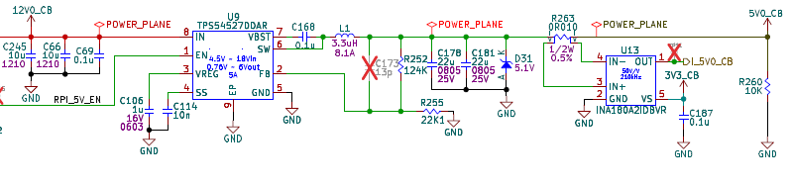
Buck qualification TPS54527DDAR

Reference
HW qualification | Reference | RPI_CM[x]_Carrier design notes
HW qualification | Applicable for | RPI_CM[x]_Carrier Rev 2.00-0A
Description |  | Detailed qualification of TPS54527 buck regulator for 5V0_CB rail
Test type |  | Internal | External | Site : Sherbrooke
Test status |  | To Do
Final test result |  | To Do

General Info
Date | 2026-03-09 | Temperature  Humidity | 25°C  50%RH
Realized by | Jean-François Bilodeau, P. Eng #6022173

System Information
Card/  Hardware | Serial Number | # Version | Mod (#WI) | Comments
Carrier Board
SOM
Accessory #1
Accessory #2

Assumptions
Based on design notes for a typical use-case:
- Typical Vout ~= 5.0V ±2%
- Typical Iout <= 3.0A
- Typical ripple ~= 20mVpp
- Typical soft start ~= 7.65ms ±15%
- Typical switching frequency ~= 740kHz

Measurement point
Measurement location for 5V0_CB Vout / Transient response qualification | Measurement location for 5V0_CB ripple qualification
Measurement location for 5V0_CB soft start qualification | Measurement location for 5V0_CB FSW qualification

Test
5V0_CB Buck qualification | Test parameters
5V0_CB Buck qualification | Target | Measurement | Result | Comments
Vout | 4.75V <= 5.0V <= 5.25V
Ripple | <= 20mVpp
Soft start | ~ 7.65ms
Operating frequency | ~ 740kHz
Temperature increase vs ambient | <= 35DegC
5V0_CB buck qualification

Figures
5V0_CB - Vout | 5V0_CB - Ripple
5V0_CB - Soft start (0-80% output voltage) | 5V0_CB - Operating frequency
5V0_CB – Temperature increase

Conclusion

Brown-out
Reference
HW qualification | Reference | RPI_CM[x]_Carrier design notes
HW qualification | Applicable for | RPI_CM[x]_Carrier Rev 2.00-0A
Description |  | Detailed qualification of TPS54527 brown-out behavior for 5V0_CB rail
Test type |  | Internal | External | Site : Sherbrooke
Test status |  | To Do
Final test result |  | To Do

General Info
Date | 2026-03-09 | Temperature  Humidity | 25°C  50%RH
Realized by | Jean-François Bilodeau, P. Eng #6022173
System Information
Card/  Hardware | Serial Number | # Version | Mod  (#WI) | Comments
Carrier Board
SOM
Accessory #1
Accessory #2
Assumptions
Must measure minimum input voltage, output voltage ramp-up (Soft start) and inrush current
Measurement point
Measurement location for 5V0_CB minimum input voltage | Measurement location for 5V0_CB soft-start validation
Measurement location for 5V0_CB EN input validation | Measurement location for 5V0_CB inrush current
Test
5V0_CB Brown-out behavior | Test parameters
5V0_CB Brown-out behavior | Target | Measurement | Result | Comments
Minimum input voltage | >= 4.5V
EN input voltage “on” threshold | >= 1.6V
EN input to output ramp-up delay | < 1ms
Inrush current | INFO
5V0_CB brown-out behavior
Figures
5V0_CB Minimum input voltage | 5V0_CB EN input voltage threshold
5V0_CB EN input to output ramp-up delay | 5V0_CB Inrush current

Conclusion

Brown-in
Reference
HW qualification | Reference | RPI_CM[x]_Carrier design notes
HW qualification | Applicable for | RPI_CM[x]_Carrier Rev 2.00-0A
Description |  | Detailed qualification of TPS54527 brown-in behavior for 5V0_CB rail
Test type |  | Internal | External | Site : Sherbrooke
Test status |  | To Do
Final test result |  | To Do

General Info
Date | 2026-03-09 | Temperature  Humidity | 25°C  50%RH
Realized by | Jean-François Bilodeau, P. Eng #6022173
System Information
Card/  Hardware | Serial Number | # Version | Mod  (#WI) | Comments
Carrier Board
SOM
Accessory #1
Accessory #2
Assumption
Must measure input voltage ramp-down, output voltage ramp-down and power good assert
Measurement point
Measurement location for input voltage ramp-down | Measurement location for output voltage ramp-down

Test
5V0_CB Brown-in behavior | Test parameters
5V0_CB Brown-in behavior | Target | Measurement | Result | Comments
Input voltage brown-in | < 4.5V
Output voltage brown-in discharge | < 10ms
5V0_CB brown-in behavior
Figures
5V0_CB Input voltage brown-in threshold | 5V0_CB Output voltage brown-in discharge (100-10%)
Conclusion

RESET
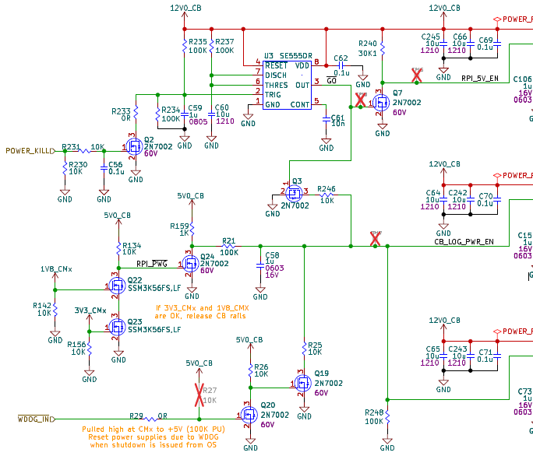
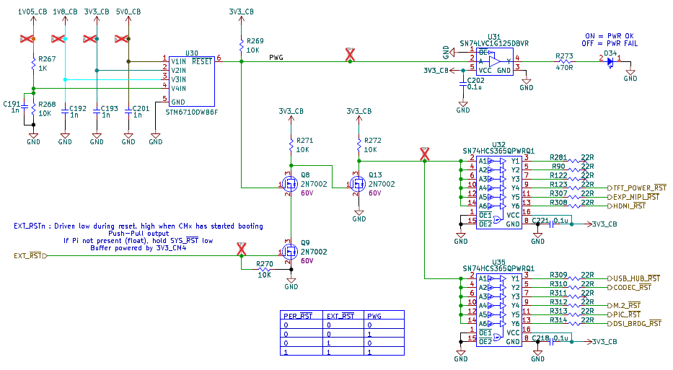

POWER-UP SEQUENCE
Reference
HW qualification | Reference | RPI_CM[x]_Carrier design notes
HW qualification | Applicable for | RPI_CM[x]_Carrier Rev 2.00-0A
Description |  | Detailed qualification of Power-up reset sequence
Test type |  | Internal | External | Site : Sherbrooke
Test status |  | To Do
Final test result |  | To Do

General Info
Date | 2026-03-15 | Temperature  Humidity | 25°C  50%RH
Realized by | Jean-François Bilodeau, P. Eng #6022173
System Information
Card/  Hardware | Serial Number | # Version | Mod  (#WI) | Comments
Carrier Board
SOM
Accessory #1
Accessory #2
Assumption
The power-up sequence is designed to meet the timings shown below:
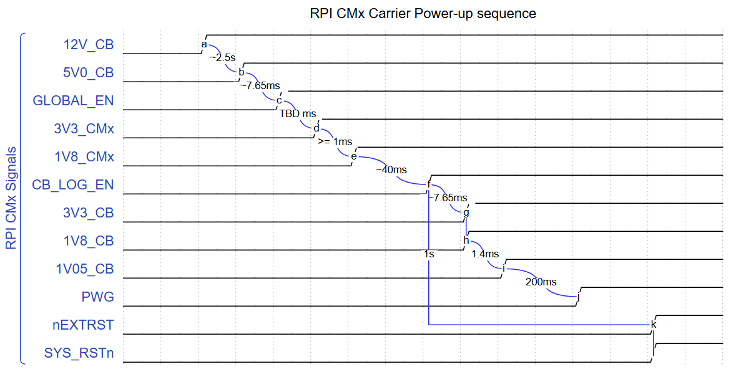
Measurement point
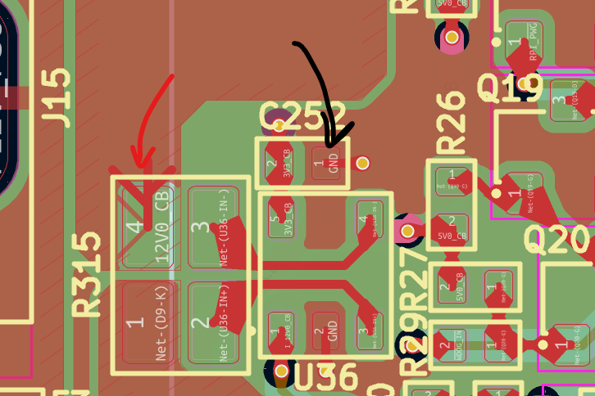  Measurement location for 12V0_CB | 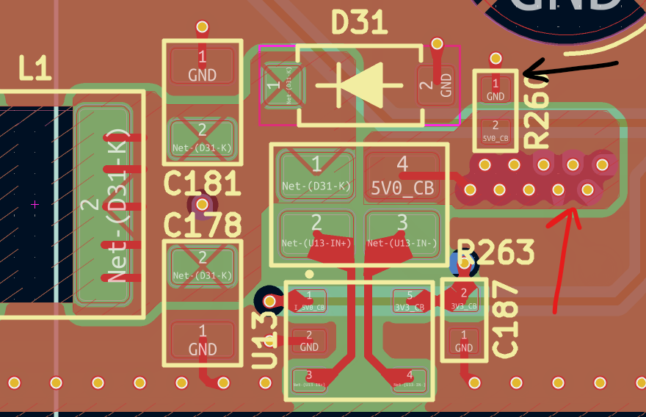  Measurement location for 5V0_CB
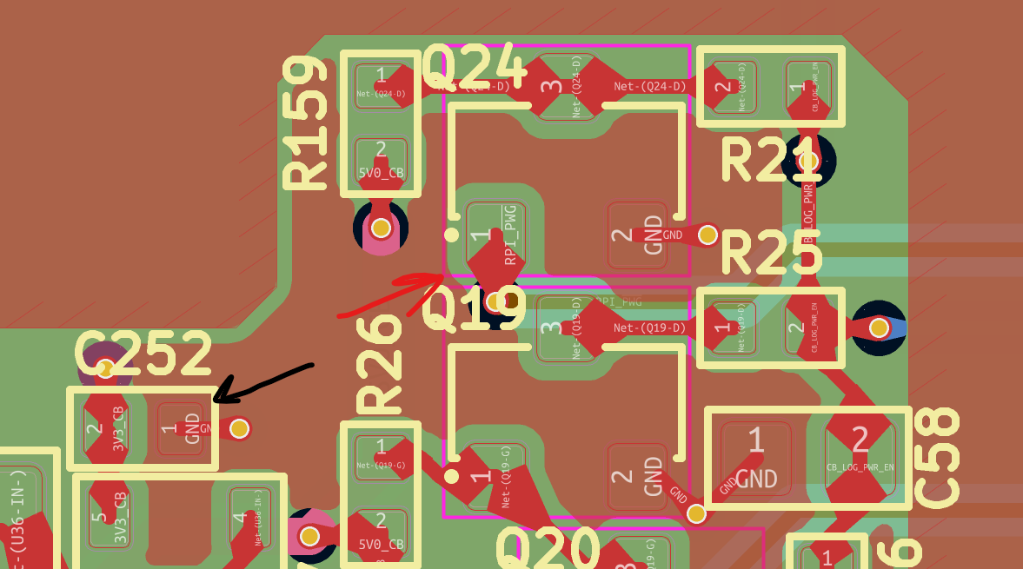  Measurement location for RPI_PWG | 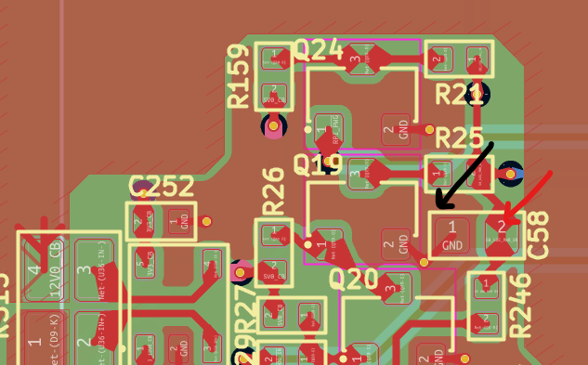  Measurement location for CB_LOG_EN
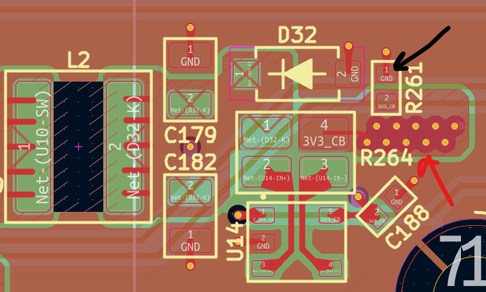  Measurement location for 3V3_CB | 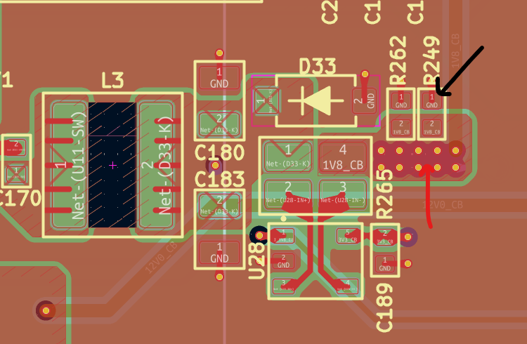  Measurement location for 1V8_CB
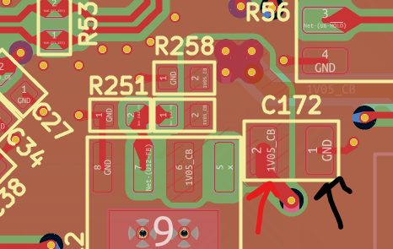  Measurement location for 1V05_CB | 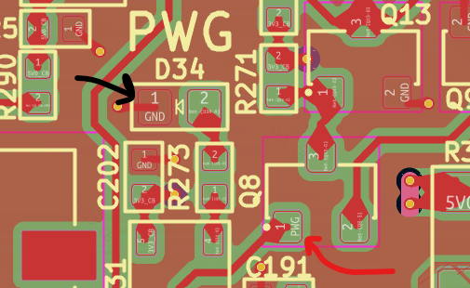  Measurement location for PWG
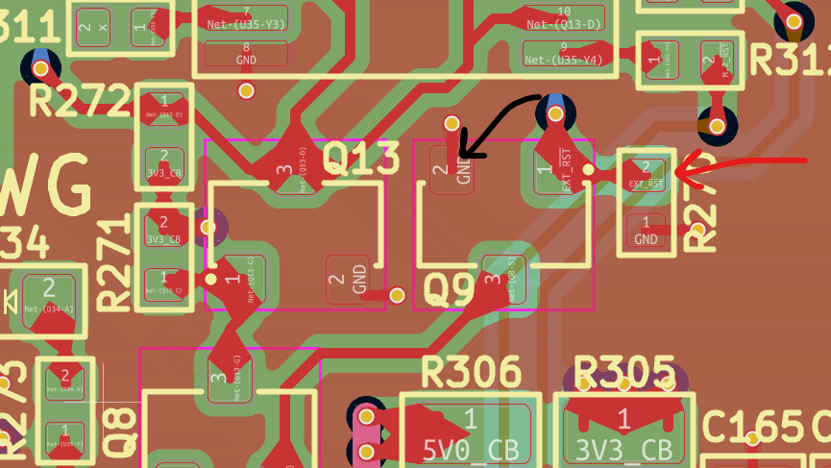  Measurement location for nEXTRST | 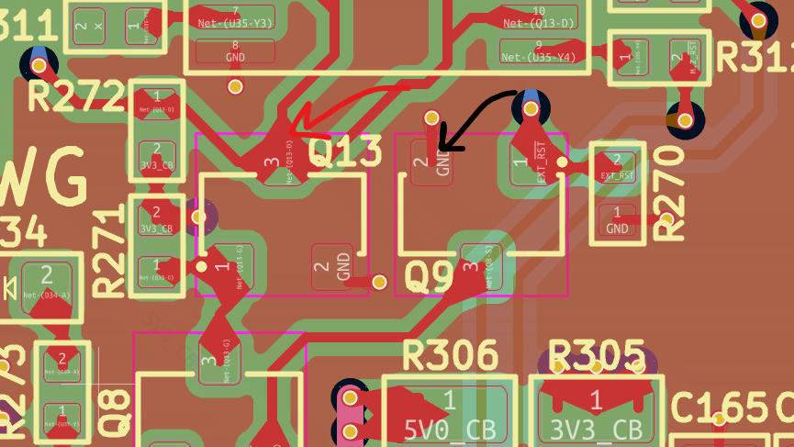  Measurement location for SYS_RSTn
Test
Power-on reset sequence | Test parameters
Power-on reset sequence | Target | Measurement | Result | Comments
12V0_CB ↑ to 5V0_CB ↑ | 2.5sec ± 10% |  |  | 2.25s <= 2.5s <= 2.75s
5V0_CB ↑ to 3V3_CMx ↑ | 7.65ms ± 12% |  |  | 6.795ms <= 7.65ms <= 8.503ms
3V3_CMx ↑ to 1V8_CMx ↑ | >= 1ms |  |  | Controlled by compute module
1V8_CMx ↑ to CB_LOG_EN ↑ | ~ 40ms |  |  | Controlled by RC filter
CB_LOG_EN ↑ to 3V3_CB & 1V8_CB ↑ | 7.65ms ± 12% |  |  | 6.795ms <= 7.65ms <= 8.503ms
1V8_CB ↑ to 1V05_CB ↑ | ~ 1.4ms
1V05_CB ↑ to PWG ↑ | 200ms ± 30% |  |  | 140ms <= 200ms <= 280ms
CB_LOG_EN ↑ to nEXTRST ↑ | 1sec |  |  | Controlled by compute module
Power-on reset sequence
Figures
12V0_CB ↑ to 5V0_CB ↑ | 5V0_CB ↑ to 3V3_CMx ↑
3V3_CMx ↑ to 1V8_CMx ↑ | 1V8_CMx ↑ to CB_LOG_EN ↑
CB_LOG_EN ↑ to 3V3_CB & 1V8_CB ↑ | 1V8_CB ↑ to 1V05_CB ↑
1V05_CB ↑ to PWG ↑ | CB_LOG_EN ↑ to nEXTRST ↑
Conclusion

WARM RESET

HARDWARE WATCHDOG

POWER KILL
Reference
HW qualification | Reference | RPI_CM[x]_Carrier design notes
HW qualification | Applicable for | RPI_CM[x]_Carrier Rev 2.00-0A
Description |  | Detailed qualification of power kill sequence
Test type |  | Internal | External | Site : Sherbrooke
Test status |  | To Do
Final test result |  | To Do

General Info
Date | 2026-03-17 | Temperature  Humidity | 25°C  50%RH
Realized by | Jean-François Bilodeau, P. Eng #6022173
System Information
Card/  Hardware | Serial Number | # Version | Mod  (#WI) | Comments
Carrier Board
SOM
Accessory #1
Accessory #2
Assumption
The power kill sequence is designed to meet the timings shown below:
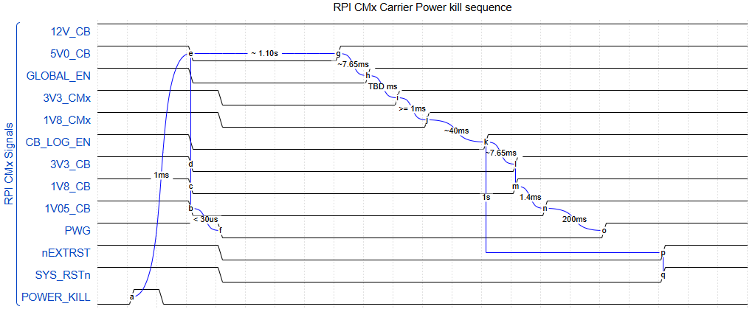
Measurement point
Measurement location for 12V0_CB | Measurement location for 5V0_CB
Measurement location for RPI_PWG | Measurement location for CB_LOG_EN
Measurement location for 3V3_CB | Measurement location for 1V8_CB
Measurement location for 1V05_CB | Measurement location for PWG
Measurement location for nEXTRST | Measurement location for SYS_RSTn
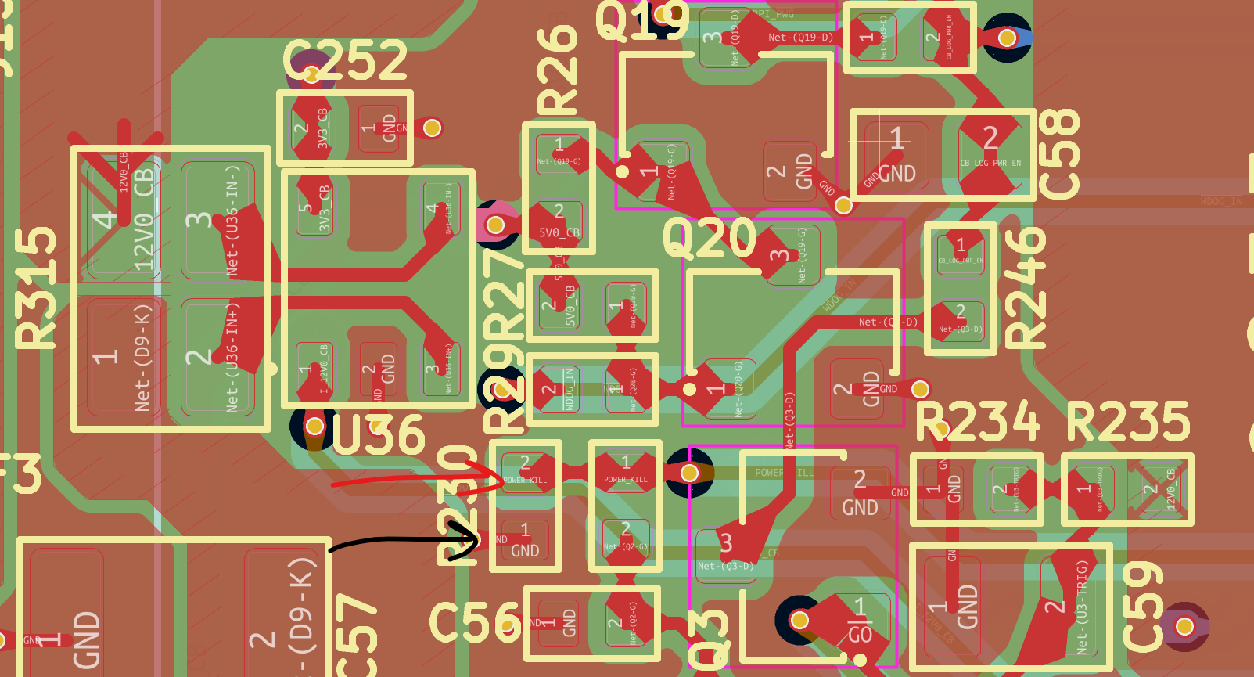
Measurement location for POWER_KILL
Test
Power kill sequence | Test parameters
Power kill sequence | Target | Measurement | Result | Comments
POWER_KILL ↑ to 5V0_CB ↓ | ~ 1ms |  |  | 2.25s <= 2.5s <= 2.75s
5V0_CB ↓ to 3V3_CB, 1V8_CB, 1V05_CB ↓ | < 10us |  |  | CB_LOG_EN ↓
5V0_CB ↓ to PWG ↓ | ~30us typ |  |  | Controlled by power supervisor T(rd)
PWG ↓ to SYS_RSTn ↓ | ~ 10us |  |  | FET + buffer propagation delay
5V0_CB ↓ to 5V0_CB ↑ | ~ 1.10s |  |  | Controlled by 555 power-up timer
5V0_CB ↑ to 3V3_CMx ↑ | 7.65ms ± 12% |  |  | 6.795ms <= 7.65ms <= 8.503ms
3V3_CMx ↑ to 1V8_CMx ↑ | >= 1ms |  |  | Controlled by compute module
1V8_CMx ↑ to CB_LOG_EN ↑ | ~ 40ms |  |  | Controlled by RC filter
CB_LOG_EN ↑ to 3V3_CB & 1V8_CB ↑ | 7.65ms ± 12% |  |  | 6.795ms <= 7.65ms <= 8.503ms
1V8_CB ↑ to 1V05_CB ↑ | ~ 1.4ms
1V05_CB ↑ to PWG ↑ | 200ms ± 30% |  |  | 140ms <= 200ms <= 280ms
CB_LOG_EN ↑ to nEXTRST ↑ | 1sec |  |  | Controlled by compute module
Power kill sequence
Figures
POWER_KILL ↑ to 5V0_CB ↓ | 5V0_CB ↓ to 3V3_CB, 1V8_CB, 1V05_CB ↓
5V0_CB ↓ to PWG ↓ | PWG ↓ to SYS_RSTn ↓
5V0_CB ↓ to 5V0_CB ↑ | 5V0_CB ↑ to 3V3_CMx ↑
3V3_CMx ↑ to 1V8_CMx ↑ | 1V8_CMx ↑ to CB_LOG_EN ↑
CB_LOG_EN ↑ to 3V3_CB & 1V8_CB ↑ | 1V8_CB ↑ to 1V05_CB ↑
1V05_CB ↑ to PWG ↑ | CB_LOG_EN ↑ to nEXTRST ↑
Conclusion

Test equipment
Description | List of available test equipment
Date | Equipment available as of 2026-03-09
Owner | Jean-François Bilodeau, P.Eng, #6022173
Equipment type | Serial Number | Description
Oscilloscope | SDS2PDDX5R1312 | Siglent SDS2154X Plus 500MHz 4ch
Multi-meter | SDM35GBX5R0999 | Siglent SDM3055
Power supply | SPD1305 | Siglent single 30V 5A PSU
Logic analyzer | Saleae logic pro 8 | A / D logic analyzer
Current probe | CP-05+ | Current probe 0-400A range

